**Question 1**: In which OSL layer the Wi-Fi standard/protocol fits.

Wi-Fi mainly works in two layers of the OSI model:

1. **Physical Layer (Layer 1)** – This is where all the actual wireless signals are transmitted. It defines things like frequencies (2.4 GHz, 5 GHz, etc.), modulation techniques, and data rates.
2. **Data Link Layer (Layer 2)** – Specifically, the **MAC (Medium Access Control) sublayer**. This handles how devices access the wireless network, manage collisions, and communicate using MAC addresses. It uses a method called **CSMA/CA (Carrier Sense Multiple Access with Collision Avoidance)** to avoid data collisions.

So, in simple terms, Wi-Fi takes care of both **how data is sent wirelessly (Physical Layer)** and **how devices communicate over the network (Data Link Layer)**.

**Question 2:** Can you share the Wi-Fi devices that you are using day to day life, share that device's wireless capability/properties after connecting to network. Match your device to corresponding Wi-Fi Generations based on properties

1. Dell Inspiron 15 (Laptop)

* Wireless Capabilities:
  + Likely supports Wi-Fi 5 (802.11ac) (depends on model; some newer models support Wi-Fi 6)
  + Dual-band support (2.4 GHz & 5 GHz)
  + Max Speed: Around 3.5 Gbps (if Wi-Fi 5)
* Wi-Fi Generation: Wi-Fi 6

2. Vivo V29E (Smartphone)

* Wireless Capabilities:
  + Supports Wi-Fi 6 (802.11ax)
  + Dual-band (2.4 GHz & 5 GHz)
  + Max Speed: Up to 9.6 Gbps (theoretical)
* Wi-Fi Generation: Wi-Fi 6

3. Lenovo M10 (Tablet)

* Wireless Capabilities:
  + Supports Wi-Fi 5 (802.11ac) (varies by model, some use Wi-Fi 4)
  + Dual-band (2.4 GHz & 5 GHz)
  + Max Speed: Up to 3.5 Gbps (if Wi-Fi 5)
* Wi-Fi Generation: Wi-Fi 5 (or Wi-Fi 4 if an older model)

4. 2.4 GHz Router

* Wireless Capabilities:
  + Only supports 2.4 GHz band
  + Likely uses Wi-Fi 4 (802.11n) or older
  + Max Speed: Around 600 Mbps
* Wi-Fi Generation: Wi-Fi 4

**Question 3:** what is BSS and ESS?

BSS (Basic Service Set) : A single Wi-Fi network with one Access Point (AP) and connected devices.

ESS (Extended Service Set): A group of multiple BSSs connected to extend Wi-Fi coverage.

|  |  |  |
| --- | --- | --- |
| Feature | BSS | ESS |
| Components | One Access Point (AP) + Multiple connected devices. | Multiple APs working together with connected devices. |
| Coverage Area | Small (limited to one AP’s range). | Large (extended coverage using multiple APs). |
| SSID (Network Name) | Single SSID per BSS. | Same SSID across multiple APs. |
| BSSID (MAC Address of AP) | Unique to each AP (MAC address of AP). | Multiple BSSIDs (each AP has a unique MAC). |
| Roaming Support | No seamless switching between APs. | Devices can move between APs without disconnecting. |
| Example | Your home Wi-Fi router connecting your Dell laptop, Vivo phone, and Lenovo tablet. | A university or office Wi-Fi where multiple APs provide seamless connectivity as you move around. |

**Question 4 :** what are the basic functionalities of Wi-Fi Accesspoint

A Wi-Fi Access Point (AP) is a device that enables wireless devices to connect to a network by transmitting and receiving radio signals over 2.4 GHz, 5 GHz, or 6 GHz frequencies. It acts as a bridge between wired (LAN) and wireless networks, allowing seamless communication. The AP broadcasts the SSID (Wi-Fi network name), enabling devices to discover and connect while enforcing security protocols like WPA2/WPA3 to prevent unauthorized access. It handles data packet forwarding, directing network traffic between connected devices and the internet. In enterprise environments, multiple APs work together in an Extended Service Set (ESS) to provide seamless roaming, allowing devices to switch APs without disconnection. Advanced APs support MU-MIMO and OFDMA to manage multiple simultaneous connections efficiently. They also offer Quality of Service (QoS) to prioritize critical traffic, guest network support, and firewall protections to enhance security. Some APs use Power over Ethernet (PoE), eliminating the need for separate power adapters. In essence, a Wi-Fi AP extends network accessibility, enhances security, and optimizes wireless connectivity for multiple devices.

**Key Functionalities of a Wi-Fi Access Point:**

* Wireless Signal Transmission – Broadcasts Wi-Fi signals for device connectivity
* Network Bridging – Connects wireless devices to a wired network.
* SSID Broadcasting – Advertises the Wi-Fi network name for easy discovery.
* Device Authentication & Security – Implements WPA2/WPA3 encryption and MAC filtering.
* Data Packet Forwarding – Manages network traffic between devices and the internet.
* Seamless Roaming (ESS Support) – Enables smooth switching between multiple APs. Multi-Device Management (MU-MIMO, OFDMA) – Efficiently handles multiple simultaneous connections.
* Quality of Service (QoS) – Prioritizes network traffic for better performance.
* Guest Network Support – Allows secure, separate Wi-Fi access for guests.
* Power over Ethernet (PoE) Support – Receives power via Ethernet, reducing cable clutter.

**Question 5 :** Difference between Bridge mode and Repeater mode

|  |  |  |
| --- | --- | --- |
| Feature | Bridge Mode | Repeater Mode |
| Purpose | Connects two different networks (wired or wireless) for seamless communication. | Extends the coverage of an existing Wi-Fi network. |
| Function | Acts as a **network bridge**, forwarding traffic between two separate networks. | Receives and rebroadcasts an existing Wi-Fi signal to cover a larger area. |
| Use Case | Used in offices or homes where multiple networks need to be connected. | Used in large homes or buildings to eliminate Wi-Fi dead zones. |
| Network Segmentation | Creates two separate subnets (may not always be the same network). | Keeps all devices on the same network (same subnet). |
| Wired Connection Support | Often connects via **Ethernet** to another network (Wireless Bridge for Wi-Fi). | Works purely **wirelessly**, no wired connection needed. |
| Speed Impact | No major speed loss since traffic is forwarded directly. | Reduces speed because data is transmitted twice (received and rebroadcasted). |
| Example Scenario | Connecting two buildings via **Ethernet or Wireless Bridge**. | Extending Wi-Fi signal to a **weak signal area** like a basement or another floor. |

* Use Bridge Mode when connecting two separate networks (e.g., linking two buildings).
* Use Repeater Mode when extending Wi-Fi coverage within the same network.

**Question 6:** what are the differences between 802.11a and 802.11b.

|  |  |  |
| --- | --- | --- |
| Feature | 802.11a | 802.11b |
| Frequency Band | 5 GHz (Less interference, better performance in crowded areas) | 2.4 GHz (Better range but more interference) |
| Maximum Speed | 54 Mbps | 11 Mbps |
| Range | Shorter range (~35m indoors, ~120m outdoors) | Longer range (~38m indoors, ~140m outdoors) |
| Interference | Less interference (5 GHz is less congested) | More interference (2.4 GHz is used by microwaves, Bluetooth, etc.) |
| Channel Availability | More channels available (less overlap, better for high-density networks) | Fewer channels, higher chance of overlap and interference |
| Adoption | Used mainly in enterprise environments | Used in homes, offices, and public spaces |
| Compatibility | Not compatible with 802.11b devices | Compatible with 802.11g (upgraded version of 802.11b) |

* 802.11a is faster (54 Mbps) but works at 5 GHz, meaning shorter range and less interference.
* 802.11b is slower (11 Mbps) but works at 2.4 GHz, offering better range but more interference.

**Question 7:** Configure your modem/hotspot to operate only in 2.4Ghz and connect your laptop/Wi-Fi device , and capture the capability/properties in your Wi-Fi device. Repeat the same in 5Ghz and tabulate all the differences you observed during this

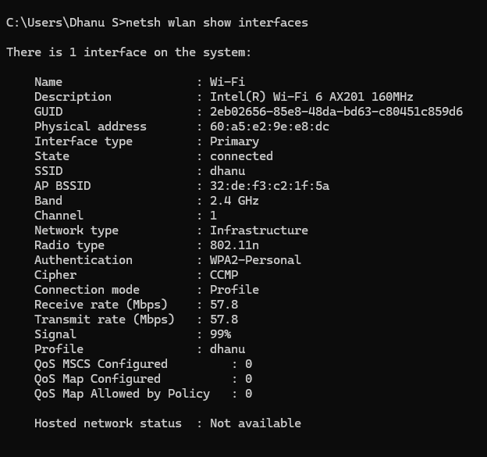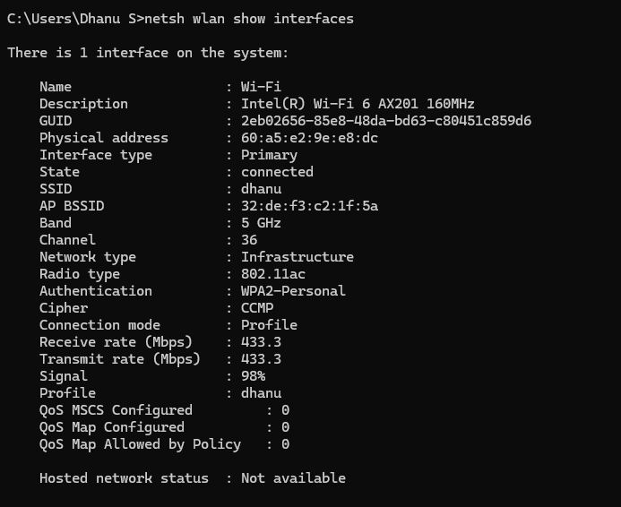

|  |  |  |
| --- | --- | --- |
| Property | 2.4 GHz Wi-Fi | 5 GHz Wi-Fi |
| Frequency Band | 2.4 GHz | 5 GHz |
| Max Speed Observed | 57.8 Mbps | 433.3 Mbps |
| Signal Strength (RSSI) | Stronger at long distances | Weaker at long distances |
| Interference Level | High | Low |
| Latency (Ping Time) | Higher | Lower |
| Range (Distance Coverage) | Longer | Shorter |
| Channel Width | 20 MHz or 40 MHz | 40 MHz, 80 MHz, 160 MHz |
| Best Use Case | General browsing, IoT devices | Streaming, gaming, high-speed downloads |

* Use 2.4 GHz if you need longer range but can tolerate slower speeds.
* Use 5 GHz for faster speeds and lower latency, but it has a shorter range.

**Question 8:** What is the difference between IEEE and WFA

|  |  |  |
| --- | --- | --- |
| Feature | IEEE (Institute of Electrical and Electronics Engineers) | WFA (Wi-Fi Alliance) |
| Full Form | Institute of Electrical and Electronics Engineers | Wi-Fi Alliance |
| Purpose | Develops global standards for various technologies, including networking, power, and computing. | Certifies Wi-Fi products for interoperability, performance, and security. |
| Role in Wi-Fi | Defines the technical Wi-Fi standards (e.g., 802.11a/b/g/n/ac/ax) | Ensures that Wi-Fi devices from different manufacturers work together smoothly. |
| Standardization | Establishes the IEEE 802.11 family of wireless networking protocols. | Provides the "Wi-Fi Certified" mark to compliant devices. |
| Regulation & Governance | Sets standards but does not enforce certification. | Enforces certification to ensure compliance with IEEE Wi-Fi standards. |
| Membership | Engineers, researchers, and tech companies | Tech companies (e.g., Apple, Intel, Cisco, Qualcomm) |
| Examples of Work | 802.3 (Ethernet), 802.11 (Wi-Fi), 802.15 (Bluetooth, Zigbee) | Wi-Fi 6, WPA2/WPA3 security certification, interoperability testing |

* IEEE creates the technical standards (e.g., 802.11 Wi-Fi protocols).
* WFA ensures Wi-Fi products follow these standards, making them compatible across devices.

Question 9: List down the type of Wi-Fi internet connectivity backhaul, share your home/college's wireless internet connectivity backhaul name and its properties

**Types of Wi-Fi Internet Connectivity Backhaul**

Backhaul refers to the connection between the Wi-Fi access point (AP) or router and the internet. There are several types of backhaul technologies used for Wi-Fi networks:

1. **Fiber Optic Backhaul**
   * **Speed:** Up to **1 Gbps – 10 Gbps** (or more)
   * **Latency:** Very low
   * **Reliability:** Extremely high
   * **Best for:** High-speed broadband, smart cities, enterprise networks
2. **Ethernet Backhaul (Wired Backhaul)**
   * **Speed:** Up to **1 Gbps – 10 Gbps**
   * **Latency:** Low
   * **Reliability:** High
   * **Best for:** Home networks, business networks, gaming
3. **Cellular Backhaul (4G/5G/LTE Backhaul)**
   * **Speed:** Up to **1 Gbps** (5G)
   * **Latency:** Medium to low
   * **Reliability:** Moderate (depends on network congestion)
   * **Best for:** Rural areas, mobile hotspots, IoT devices
4. **Microwave Backhaul (Point-to-Point Wireless)**
   * **Speed:** Up to **1 Gbps**
   * **Latency:** Low
   * **Reliability:** High but weather-dependent
   * **Best for:** Remote locations, enterprise networks
5. **Satellite Backhaul**
   * **Speed:** Up to **100-500 Mbps** (Starlink, traditional satellite)
   * **Latency:** High (due to distance from satellite)
   * **Reliability:** Moderate (affected by weather, obstructions)
   * **Best for:** Remote areas, ships, aircraft
6. **Mesh Wi-Fi Backhaul (Wireless Backhaul in Mesh Networks)**
   * **Speed:** Varies based on distance and interference
   * **Latency:** Medium
   * **Reliability:** High but depends on node placement
   * **Best for:** Large homes, office buildings, campuses

**Home/college's wireless internet connectivity backhaul name**

* **Cellular backhaul**
* **Ethernet Backhaul**
* **Fiber Optic Backhaul**
* **Mesh Wi-Fi Backhaul**

**Question 10:** List down the Wi-Fi topologies and use cases of each one

**Wi-Fi Topologies and Their Use Cases**

1. **Infrastructure Mode (BSS - Basic Service Set)**
   * Devices connect to a central Access Point (AP).
   * The AP manages communication and internet access.
   * Use Cases:
     + Home Wi-Fi networks
     + Offices & corporate networks
     + Public Wi-Fi hotspots
2. **Extended Service Set (ESS)**
   * Multiple APs are interconnected via a wired backbone.
   * Expands Wi-Fi coverage seamlessly.
   * Use Cases:
     + Large buildings (offices, malls)
     + Universities & schools
     + Airports & hotels
3. **Ad-Hoc Mode (IBSS - Independent Basic Service Set)**
   * Devices communicate directly without an AP (peer-to-peer).
   * No need for a central network infrastructure.
   * Use Cases:
     + File sharing between devices
     + Temporary networks (disaster relief, military)
     + IoT device communication
4. **Mesh Wi-Fi Network**
   * Multiple APs create a self-healing, interconnected network.
   * Eliminates Wi-Fi dead zones with seamless roaming.
   * Use Cases:
     + Smart homes
     + Large offices & factories
     + Public Wi-Fi in parks & cities
5. **Wi-Fi Direct**
   * Devices connect without a router/AP, like Bluetooth but faster.
   * Enables quick, high-speed file transfers.
   * Use Cases:
     + Wireless printing
     + File sharing (phones, laptops)
     + Gaming console connections
6. **Hotspot Network (Captive Portal)**
   * Requires user authentication before accessing Wi-Fi.
   * Often used for public or commercial networks.
   * Use Cases:
     + Hotels, cafes, airports
     + Public Wi-Fi services
     + Corporate guest networks
7. **Point-to-Point (P2P) & Point-to-Multipoint (P2MP) Wi-Fi**
   * Wireless links between two or more locations.
   * Used for long-distance, high-speed communication.
   * Use Cases:
     + Wireless ISP networks
     + Connecting buildings wirelessly
     + Surveillance & security networks